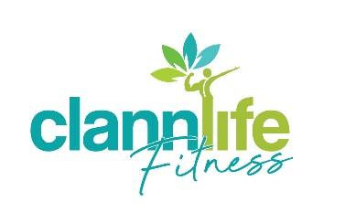
DISABILITY INCLUSION POLICY
The mission of Clannlife Fitness is to value the ability and individuality of people with disabilities by providing each individual with the opportunities they need to reach their full potential as participants within an inclusive ethos/culture.
At Clannlife Fitness we will achieve disability inclusion by continually reviewing an approach that is implemented by the members, staff and management and by working in partnership with clubs, disability services and in consultation with people with disabilities and their families. This will ensure that our organisation is inclusive for everyone.
Our organisation welcomes all members of the community, regardless of their abilities. We will include people with disabilities in our organisation in both playing and non-playing roles to the greatest extent that we can. We will endeavour to make our organisation as inclusive and accessible as possible, based on our commitment to comply with the Equal Status Acts 2000-2012, the Disability Act 2005 and Article 30.5 of the United Nations Convention on the Rights of Persons with Disabilities. We are also committed to fulfilling the requirement of the Sports Ireland Policy on Participation in Sport by People with Disabilities and to signing and engaging with the Sport Inclusion Disability Charter.
We are committed to ensuring that as far as reasonably practicable, our organisational environment, clubs, training and physical facilities are accessible to people with disabilities. We are ready to consider all reasonable adjustments that would, over time, help us to achieve this aim more fully and effectively.
We have 8 Disability Car parking Spaces directly outside of Clannlife Fitness & similar outside the hotel itself.
Presently, we have a pool which is 1.35m in depth and has sloped steps at 3 different entrances into the water. We have an accessible changing room/bathroom with shower and WC. There is easy access to this changing room from our Reception area which has a area of our desk suitable for wheelchair users, plus easy access from the changing room to our pool. Our staff, including Lifeguards are trained and there to assist you if you need it entering or exiting the water. Our pool temperature is kept at a comfortable temperature between 30 degrees & 32 degrees. We run swimming lessons which are inclusive and welcoming of people with disabilities and also provide one to one private lessons.
With accessible lifts from the hotel our gym can be accessed from the 1st floor through double doors. In the gym there is plenty of room and everything is of bright colour. We have the following which are wheelchair accessible:
- The Dual Adjustable Pulley – can be used for a variety of strength training exercises including tricep extension, pulldown, bicep curls, chest press & many more.
- The Ski Erg – can be used for both cardio & strength work as the user can adjust the resistance.
- The Assualt Bike – can be used with arms only, legs only or both as a cardio machine.
- Free weights – perfect for a variety of strength exercise & suitable standing, sitting down.
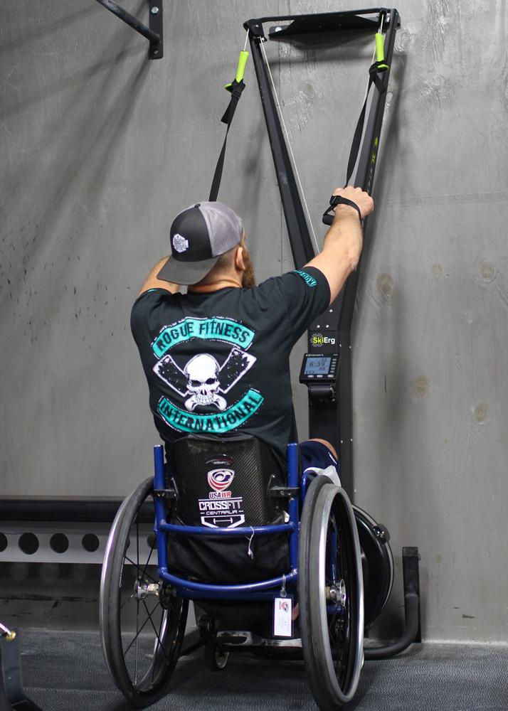
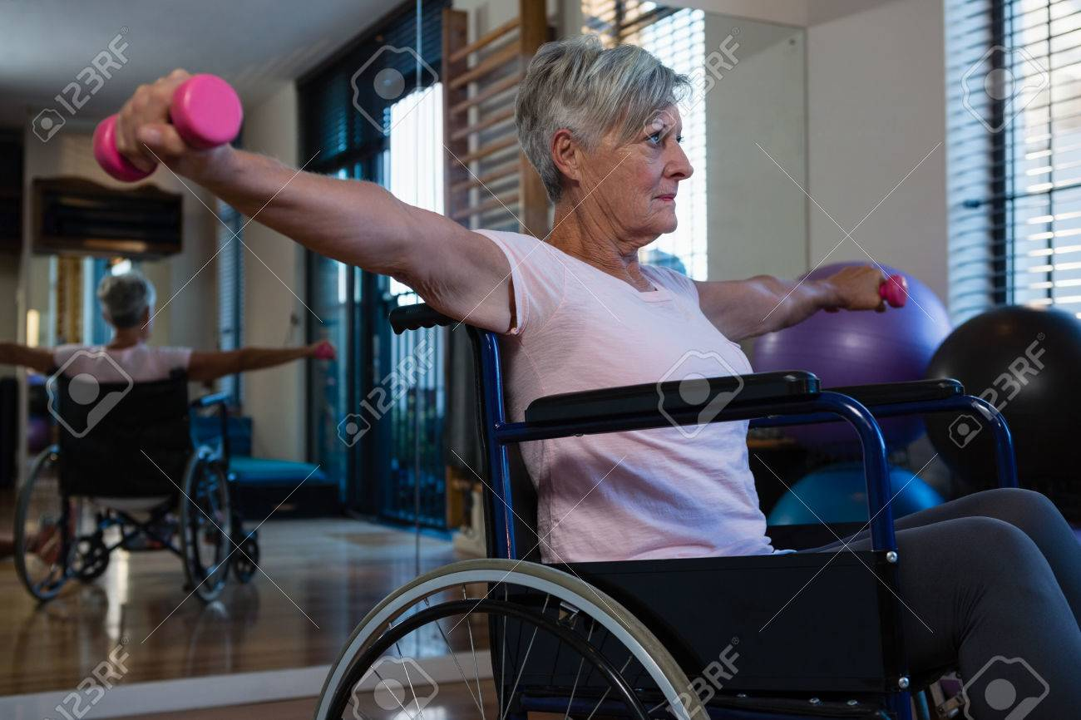
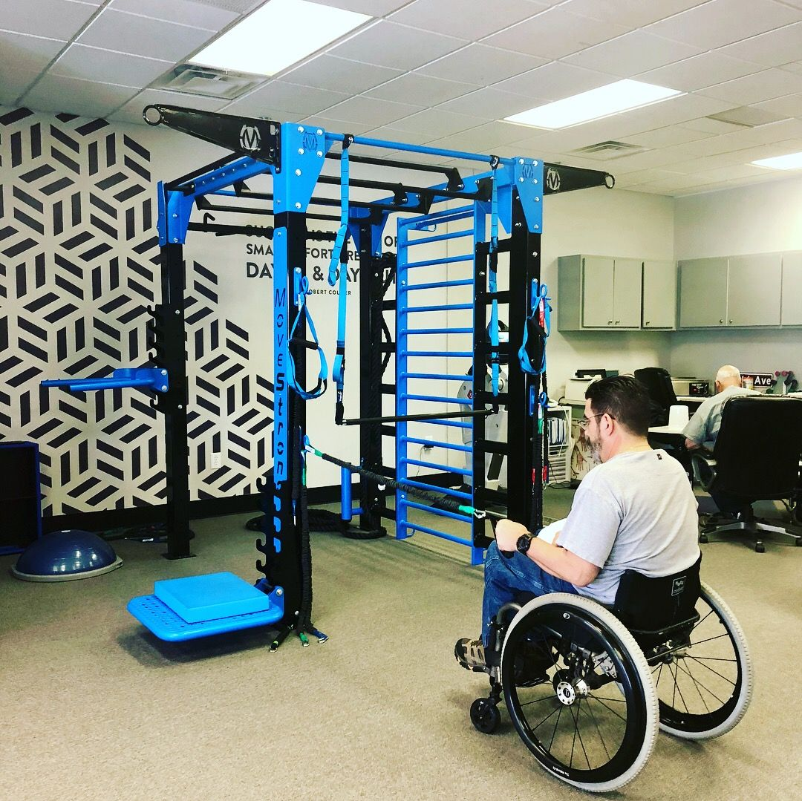

By developing our capacity and capabilities within our organisation we will strive to deliver inclusive programmes, promote and advocate for disability inclusion and increase the numbers of people with disabilities participating in our sport and organisation.
In our efforts to deliver on this we will:
• Adopt an inclusive approach across all aspects of the entire organisation by consulting with our members
• Consult with and listen to the voices of people with disabilities in all of our deliberations and programme development
• Work in partnership with other organisations and individuals who are advocates for the inclusion of people with disabilities
• Promote good governance across the entire organisation to ensure that participation of people with disabilities is delivered
• Acknowledge and support the contributions, achievements and successes of people with disabilities in our organisation
• Commit to and adopt the Sport Inclusion Disability Charter

We will annually review our Disability Inclusion Policy to meet as far as possible to requirements of each individual to provide them with the opportunity they need to reach their full potential.

Clannlife Fitness
Updated May 2021

